MAE6220 FINAL EXAM

Name:___________________________________ Time: 2hrs

Question 1:

1. Consider the following finite-difference formula for the second derivative $δ^{2}ϕ/δx^{2}$ on a uniform grid with spacing $h$:

$$\frac{δ^{2}ϕ}{δx^{2}}=\frac{\frac{35}{12}ϕ_{i}-\frac{26}{3}ϕ_{i+1}+\frac{19}{2}ϕ_{i+2}-\frac{14}{3}ϕ_{i+3}+\frac{11}{12}ϕ_{i+4}}{h^{2}}$$

Using Taylor series expansions demonstrate the formal order of accuracy of the above formula.

1. Consider the uniform grid shown in the figure. Construct a one-sided finite-difference formula, which is 2nd order accurate, to compute the first derivative, $∂φ/∂x$, at point $i$ on the wall (Figure 1).

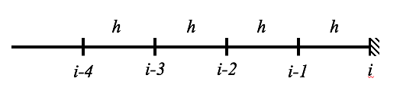

Figure 1.

Question 2: Consider the following equation where $c$ is a constant.

$$\frac{∂ϕ}{∂t}-c\frac{∂ϕ}{∂x}=0 (Eq. 1)$$

1. If the equation is discretized using the implicit scheme below, determine the consistency of the discretization scheme.
$$\frac{ϕ_{i}^{n+1}-ϕ_{i}^{n}}{Δt}-c\frac{ϕ_{i+1}^{n+1}-ϕ_{i-1}^{n+1}}{2Δx}=0$$

2. Examine the stability of Eq.1 for the grid shown in Figure 2 using a forward differencing scheme for discretization in space for the boundary condition $ϕ\left(t,L\right)=a$.

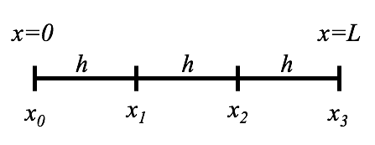  
Figure 2.

Question 3: Consider the two-dimensional energy transport equation for an incompressible inviscid fluid.

$$ρC_{p}\left(\frac{∂T}{∂t}+u\frac{∂T}{∂x}+v\frac{∂T}{∂y}\right)=k\left(\frac{∂^{2}T}{∂x^{2}}+\frac{∂^{2}T}{∂y^{2}}\right)$$

where $T$ is the absolute temperature, $C_{p}$ is specific heat for constant pressure, $k$ is thermal conductivity of the fluid and $ρ$ is density. $ρ, C_{p}, k, μ$ are all constants.

1. Derive the Reynolds average of the equation and describe all terms. State all relevant assumptions.
2. Which term(s) need to be modeled? What are the possible strategies to model the term(s).